Redwood Curtain Disc Golf Course: ecology and elevation analysis for a scenic recreational park in Arcata, California
By: Taylor McCracken
12 May 2016
Abstract
There were two primary goals for this project. The first was to collect waypoints for relevant features in the field and produce a reference map of the Redwood Curtain Disc Golf Course. The second was to use the information collected in the field to analyze the topography and elevation of the course. In addition, the ecology of the coast redwood forest ecosystem in which the park was constructed, and the impact of the human presence in parks like this will also be discussed. Waypoints were collected using a Garmin handheld global positioning system (GPS). Maps were produced using ArcMap. Analysis of elevations and distances were conducted using Microsoft Excel. The final results show that the Redwood Curtain can be treated as two separate courses, with different topographical and gameplay features.
Introduction
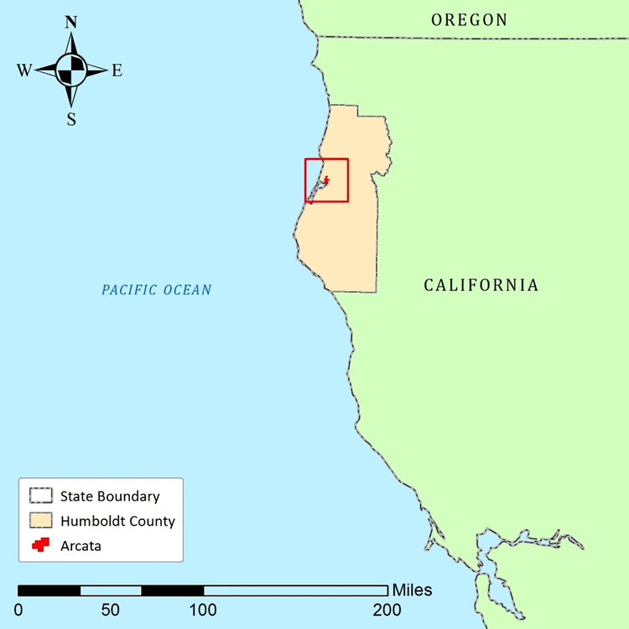
Figure 1. Location of Arcata in Humboldt County, California

The Redwood Curtain is a moderately sized disc golf course located behind the Humboldt State University Campus in Arcata, California (see Fig. 1). It is an eighteen-hole course, ten of which offer alternative basket positions. The Park is positioned in the foothills in a mixed coast redwood (Sequoia sempervirens) and Douglas-fir (Pseudotsuga menziesii) forest, and borders the Arcata Community Forest. Because there was little documentation of the positions of the tee pads, much less the trails that link them together, the principle goal for this project was to collect waypoints for baskets and tee pads and produce a reference map for this unique recreational park. The ecology of this course and the Arcata Community Forest was taken into consideration, including native species of flora and fauna and how they can be preserved for our appreciation and enjoyment in parks like these.
Methods
Waypoints for the tee pads and baskets were collected directly using the ‘Waypoint Averaging’ function on my Garmin handheld device. Once collected, the waypoints were updated once a day for five sequential days and at different times. This was done in order to capitalize upon the changing positions of the GPS satellites used by the handheld to determine position, thereby increasing the precision and accuracy of the waypoints. Via this process, the elevation data was likewise updated for accuracy and precision. With the waypoints collected, they were then exported from the Garmin device to a computer using the Garmin program Basecamp. The waypoints were then exported as point shapefiles and as a Microsoft Excel spreadsheet of the data, from which the following tables were derived (see Results). Other relevant vector data for rudimentary features such as roads and water features were collected from online from sources including the official Humboldt County geographic information system (GIS) page and Natural Earth. The final maps were produced using the geospatial program ArcMap. In this program, features such as the trails, trees, and stumps, as well as the lines plotting the recommended disc flight path were digitized by editing the layer of waypoints. A boundary for both divisions was digitized by creating a polygon file composed of the outermost of all the collected representative points. A buffer of 25 feet was then applied to the new polyline, and this buffer was used to depict a rough boundary for each division. The final map was then furnished with the necessary cartographic elements. Using Excel, the tabular data for the collected waypoints was organized and used to produce a series of scatter plots showing elevation and distance data for each basket and tee pad.
Results
The Redwood Curtain can be divided into a southern region containing the first ten tee pads, and a northern region containing the remaining eight. The southern division (Fig. 2a) is oriented east-west, and disc paths run either uphill or downhill, in a series. The southern division of the course occurs at a higher elevation than the northern division (see Fig. 4a), and the average distance, as the crow flies, between each tee pad and basket is higher for this first division (see Table 1; Fig. 3). The northern division (Fig. 2b) is likewise oriented east-west, but is situated on much steeper slopes than the southern. The northern portion is a shorter average distance between tee pads and baskets than in the southern; however, the elevation difference here is much greater. In the northern part of the course, many of the disc flight paths run perpendicular to the incline of the hills. The Redwood Curtain Disc Golf Course can be regarded as two separate, proximate courses: an initial ten holes where distance and obstacles are the challenge, and a second round of eight holes where the challenge lies in the steeper elevation.
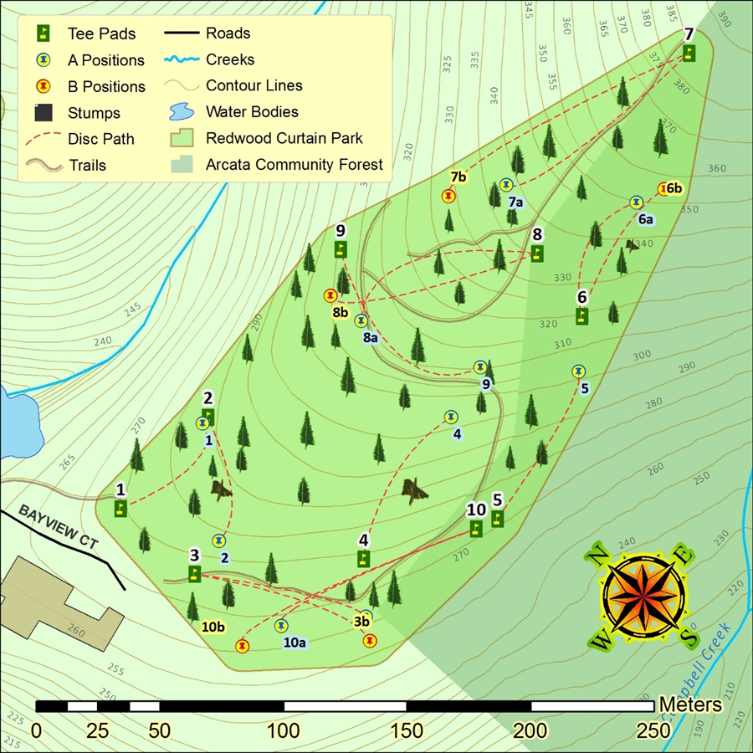
Figure 2a. The southern division of the course, containing the first ten holes. This portion of the course is east-west oriented and occurs at a higher elevation than the second northern portion. Note the contour lines; the difference in elevation between locations here is moderate. Here, stumps and tall trees represent the majority of obstacles for each fairway.

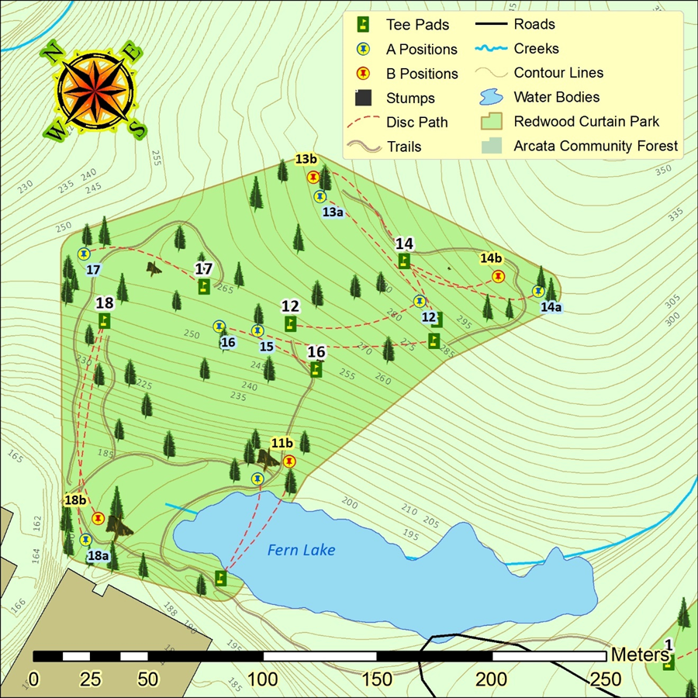
Figure 2b. The northern, second division of the course containing the remaining eight holes. Here the contour lines are close together, indicating a higher degree of elevation change between locations here than in the first division. Here, Fern Lake acts as a hazard element in the course; A disc released from tee pad #11 must clear the lake or be lost in it.

Table 1. Here is the elevation and distance data for each tee pad and basket. For the tee pads, the difference in elevation between each tee pad and the one that precedes it is calculated. Baskets occurring in the southern division are listed in the center column, and baskets occurring in the northern division are listed in the right-hand column.
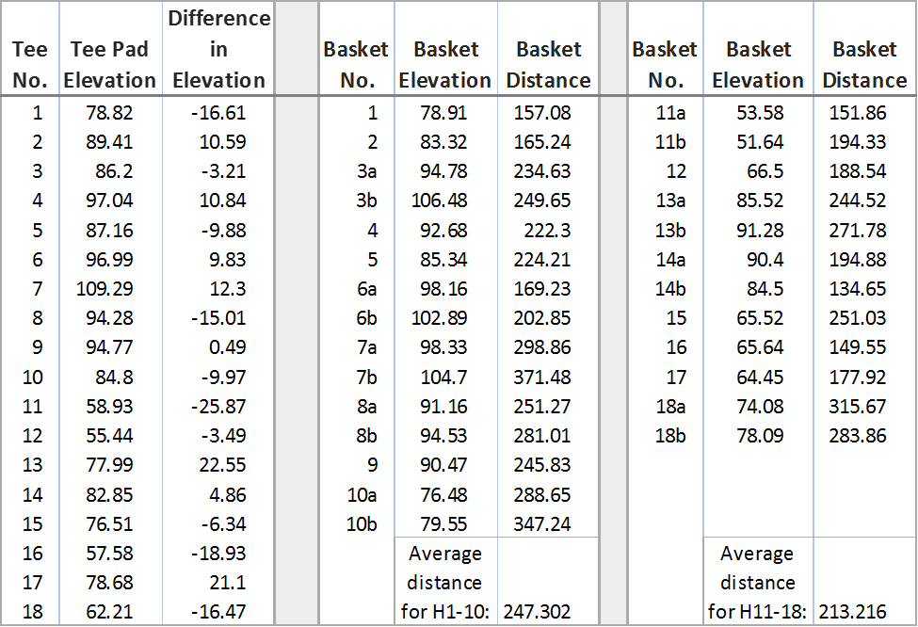

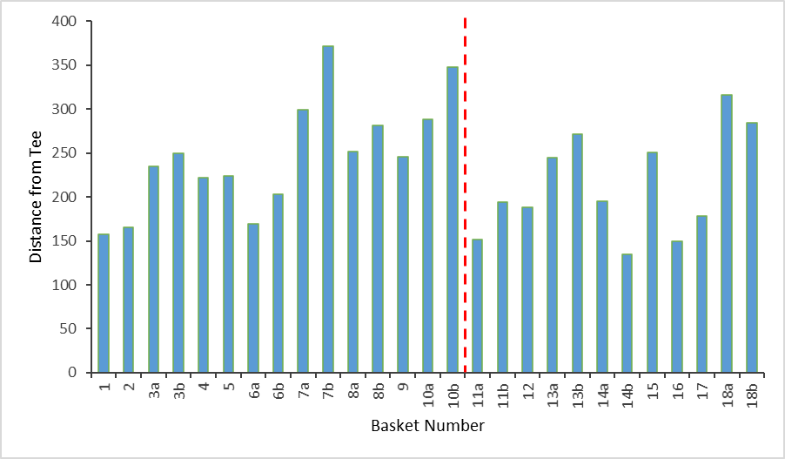
Figure 3. A bar graph showing the distance in feet of each basket from its associated tee pad. The dashed red line indicates the separation between the first, southern division of the course and the second, northern division of the course.
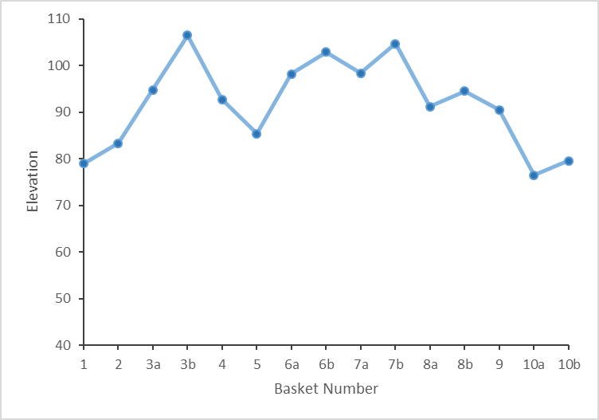
Figure 4a. A scatter plot showing the elevation of each basket for the southern division of the course.

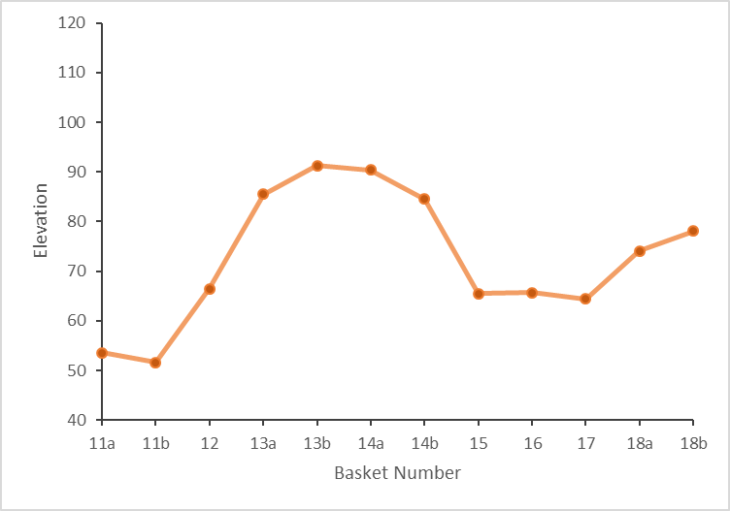
Figure 4b. A scatter plot showing the elevation data for each basket in the northern division.
Discussion
In addition to being a convenient recreational site, the Redwood Curtain also hosts a scenic representation of some of Humboldt County’s own flora and fauna. The park is home to many species of birds, lizards, snakes, rodents, wildflowers, ferns, and of course, trees. The dominant trees are the coast redwood and the Douglas-fir, intermingling with Sitka spruce (Picea sitchensis) and the regnant grand fir (Abies grandis) (Baldwin et al. 2012). The sunnier patches of the forest play host to huckleberry (Vaccinium spp.), red elderberry (Sambucus racemosa), and red alder (Alnus rubra) (Baldwin et al. 2012). While playing a round of golf or hiking the trails that wind through the course, one might hear or see a belted kingfisher (Megaceryle alcyon) perching over Fern Lake, or the tapping of a red-breasted sapsucker (Sphyrapicus ruber), or the rustling of a wrentit (Chamaea fasciata) in the bushes (Sibley 2003). Lizards and snakes are a common sight on sunny days, as well. In late March, when the waypoints for this project where collected, the wildflowers were blooming. The trillium (Trillium spp.) in particular were blooming in droves (Baldwin et al. 2012). Because the course is only moderately developed, the native ecology here continues only mildly interrupted, and available for players and passerby alike to enjoy. Though disc golf courses may host a healthy number of native species, the constant presence of humans can also have a negative impact on soil and vegetation cover (Trendafilova and Waller 2011). The high volume of human foot traffic around baskets and between tee pads leads to higher rates of soil compaction and decreasing vegetation cover immediately near these features (Trendafilova and Waller 2011). The increased soil compaction also leads to a lower rate of water retention and thus water-loss by the soil (Trendafilova and Waller 2011). Course managers can install alternate basket positions which decreases the amount of stress each area may receive by rotating the basket placements (Trendafilova and Waller 2011). To this end, ten of the holes in the Redwood Curtain have alternate positions. The application of mulch can also dampen the impact of high volumes of foot traffic (Trendafilova and Waller 2011). The greatest long-term solution is careful management and a fostering of value by players in the natural elements of the course (Trendafilova and Waller 2011).

Conclusion
The Redwood Curtain Disc Golf Course is a scenic and enjoyable recreational park, but the extent of the course and the location of its tee pads and baskets was previously poorly documented and thus difficult to navigate in practice. Now, spatial data has been collected and documented for these features, and a map produced which clearly displays their locations and how to find them in order and complete a proper round. Analysis of the elevation data collected revealed that the Redwood Curtain is almost comprised of two separate courses, both different from each other in terms of topography and the challenges they pose. The first, or southern division occurs on a moderate slope, but many of the tee pads require shots over long distances. The second, or northern division has shorter distances between tee pads and baskets, but the elevation change is much greater than in the southern, presenting a potential fairway hazard. The Redwood Curtain as a whole offers a unique and challenging round of golf, in addition to a scenic showcase of some of the flora and fauna native to Humboldt County and the North Coast. For future analysis, a 1:1-meter resolution digital elevation model (DEM) of Arcata would allow for raster analysis of the area, and thus more accurate models of slope, hill-shade, and aspect which cannot be achieved with the contour vectors applied in this analysis. A more intensive evaluation of the effect of recreational parks such as disc golf parks and the human impact on natural systems in these parks could also offer potentially valuable knowledge on their proper management.

Acknowledgements
I would like to thank the Humboldt County Planning and Building Department, for providing the vector data for Humboldt County roads and city boundaries; and to the City of Arcata Environmental Services Department for providing the vector data for rivers, water bodies, and contour lines in Arcata. I would also like to thanks Sarah Matthews and Dr. Mary Beth Cunah for providing polygon data for Humboldt State University campus and buildings. I would also like to thank Natural Earth, for providing polyline data for the state boundaries used in the locator map. I would especially like to thank everyone at work Geospatial Science program, for their work in providing myself and my fellow students with the knowledge, resources, and tools necessary to succeed in our endeavors. Thank you all.

Citations
Humboldt County Official Webpage [HCG]. 2013. Humboldt County GIS data download. <http://humboldtgov.org/276/GIS-Data-Download>. Accessed 14 April 2016.
City of Arcata Official Website [COA]. 2016. Maps/GIS. <http://www.cityofarcata.org/322/MapsGIS>. Accessed 14 April 2016.
Natural Earth [NE]. 2016. 1:10m cultural vectors; states and provinces. <http://www.naturalearthdata.com/downloads/10m-cultural-vectors/>. Accessed 28 April 2016
Baldwin, B. G., D. H. Goldman, D. J. Keil, R. Patterson, T. J. Rosatti, and D. H. Wilken, editors. 2012. The Jepson manual, vascular plants of California. Second edition. University of California Press, Berkeley and Los Angeles, California, USA.
Sibley, D. A. 2003. The Sibley field guide to birds of Western North American. Knopf, New York City, New York, USA.
Trendafilova, S. A., and S. N. Waller. 2011. Assesing the ecological impact due to disc golf. International Journal of Sport Management Recreation & Tourism, 8: 35-64.

